Visualizing Genre-Based Writing Development in an EAP Course Using Performance Charts and LMS Engagement Indicators: An Action-Research Study
Raheb Zohrehfard, Gerry Tillman
EAL/EAP Department, Alexander College, Vancouver, Canada

Abstract
This action-research study examines how “performance charts” (distributional histograms and trend lines derived from routine course assessment data) can support the visualization and interpretation of genre-based writing development in an English for Academic Purposes (EAP) course. Learner outcomes were operationalized as rubric-based scores on three core genres taught sequentially across the term—(a) comparison–contrast, (b) cause–effect, and (c) an argumentative research paper—supplemented by learning management system (LMS) engagement indicators (weekly page views and participation events). Using de-identified gradebook exports and LMS analytics, we produced performance charts for each genre task and examined (i) shifts in mean performance and score distributions and (ii) the extent to which engagement patterns co-occurred with performance trends. Results show modest changes in mean scores across the three genres alongside persistent dispersion, suggesting uneven uptake of genre demands and research-integrative writing practices. The paper contributes a transparent, replicable workflow for converting routine EAP assessment and LMS data into interpretable performance visualizations that can inform formative program evaluation and targeted instructional decision-making.
Keywords: English for Academic Purposes (EAP); genre-based writing; writing development; learning analytics; assessment; performance charts
1. Introduction
Genre-based EAP writing courses typically rely on repeated performance evidence (assignments, rubrics, drafts, and revisions) to support students’ academic literacy development. Yet, instructors and program leads often lack concise ways to visualize cohort-level development and variability across genres, beyond individual feedback and single-point averages. In parallel, LMS platforms produce learning analytics (e.g., page views, discussion participation) that are frequently consulted informally but are rarely integrated into transparent assessment-based interpretations of writing development. This paper addresses both needs by proposing “performance charts” as a pragmatic visualization layer: distributions and trends generated directly from routine assessment and LMS data to support interpretation, reflection, and instructional decision-making in EAP contexts.
The study is guided by three questions:
RQ1. What do performance charts reveal about cohort-level writing performance and variability across three taught genres over one academic term?
RQ2. Which rubric dimensions and genre demands appear most challenging when performance distributions are examined alongside instructor notes and rubric profiles?
RQ3. How do LMS engagement indicators (page views and participation) trend across the term, and how do they descriptively relate to writing performance patterns?
2. Literature Review
Two strands of scholarship inform this study: (a) genre-based academic writing and assessment in EAP/ESP, and (b) the visualization of learning and performance data in educational contexts.
Genre-based approaches conceptualize academic writing as patterned social action, where students learn not only linguistic resources but also disciplinary rhetorical moves, organization, stance, and evidence practices. Within EAP, genre-oriented pedagogy is often implemented through explicit modeling, deconstruction, joint construction, and independent construction, with analytic rubrics used to evaluate dimensions such as thesis control, organization, language resources, and conventions.
In assessment research, the validity and usefulness of locally-developed rubrics depend on clear construct definition, transparent scoring procedures, and evidence of reliability. For integrated and research-oriented writing tasks, studies highlight the need to ensure that rubric criteria reflect the subskills being targeted (e.g., argumentation, source integration, and synthesis) and that raters share a common interpretation of descriptors.
Separately, learning analytics work suggests that simple indicators (e.g., page views, participation counts) can approximate exposure and interaction, but these metrics can be ambiguous and are best interpreted as contextual signals rather than direct proxies for learning. A key practical gap is methodological: EAP programs rarely report a clear workflow that links routine gradebook data and LMS analytics to interpretable visualizations that support program-level reflection without overclaiming. The present study situates performance charts as a modest, transparent response to this gap: they are not a new psychometric model, but a replicable descriptive layer for diagnosing patterns of attainment and engagement over time.
3. Method
3.1 Design
The study adopts an action-research design in which routine classroom assessment data are repurposed for systematic reflection and local program improvement. The analytic stance is descriptive and diagnostic rather than causal.
3.2 Context and Participants
The study was conducted in a credit-bearing EAP writing course at a Canadian college. Students were multilingual learners preparing for undergraduate studies. The cohort size was 25, and the course ran from mid-April through mid-June. Ethical safeguards included de-identification of student records and aggregation at cohort level.
3.3 Writing Tasks and Scoring
Three genre tasks were analyzed in the order taught: (1) Comparison–Contrast Essay (due 18 May), (2) Cause–Effect Essay (due 26 May), and (3) Argumentative Research Paper (due 15 June). All tasks were scored using analytic, genre-sensitive rubrics aligned to course outcomes. Across tasks, rubric dimensions included: (a) thesis/focus, (b) organization/development, (c) language use (lexico-grammar and academic register), and (d) conventions (mechanics, formatting, and citation). Scores were recorded as percentages in the LMS gradebook.
Following established practices in L2 writing assessment (McNamara, 1996; Knoch, 2009), inter-rater reliability was examined through double marking of a randomly selected 20% of scripts by a second instructor. Both raters had undergone prior calibration using the program’s shared analytic writing rubric, and scoring was conducted independently.
Consistency of scoring was assessed using the intraclass correlation coefficient (ICC) for total scores, as recommended for continuous measures derived from analytic rating scales (McNamara, 1996). The estimated ICC for total scores was approximately .82, indicating good to very good agreement and suggesting that the rubric functioned as a stable measurement instrument across raters. Observed score differences were largely confined to borderline performances, a pattern commonly reported in analytic writing assessment (Knoch, 2009).
To further examine agreement at the level of rubric categories, weighted Cohen’s kappa was also calculated, yielding substantial agreement (κ ≈ .70–.75). This convergence between continuous and categorical reliability indices provides additional support for the dependability of the scoring process.
As noted by McNamara (1996), reliability estimates are inherently context dependent. In the present study, reliability is constrained by the reuse of an existing institutional rubric and the single-institution context, which may limit the generalizability of reliability coefficients to other programs, rater populations, or assessment tasks. Consequently, the reported reliability should be interpreted as evidence of local scoring consistency rather than as a claim of universal rubric stability.
3.4 LMS Engagement Indicators
Two engagement indicators were extracted from the course LMS analytics: (a) weekly average page views per student and (b) weekly average participation events per student (e.g., posts/replies or other recorded interaction events; the platform was Canvas). These indicators were treated as coarse proxies for exposure and interaction, not direct measures of learning.
3.5 Data Preparation and Performance Charts
De-identified gradebook exports were used to compute descriptive statistics (mean, minimum, maximum) and to generate score distribution histograms for each task. The LMS analytics export was used to plot weekly trends in page views and participation. All charts are reported with axes representing score percentages (x-axis) and frequency (y-axis) for histograms, and weekly time (x-axis) and average counts (y-axis) for engagement trends.
3.6 Analysis
RQ1 was addressed via comparison of task-level means and distributional patterns across the three genres. RQ2 was addressed via rubric-profile interpretation (dimension-level patterns) and instructor notes; where dimension-level data were not available in exports, interpretation was restricted to overall-score patterns and rubric-informed qualitative observations. RQ3 was addressed via descriptive comparison of engagement trends with the timing of major writing tasks, supplemented by exploratory correlations between engagement indicators and task scores (reported without causal claims).
4. Results
4.1 Genre Task Performance Charts

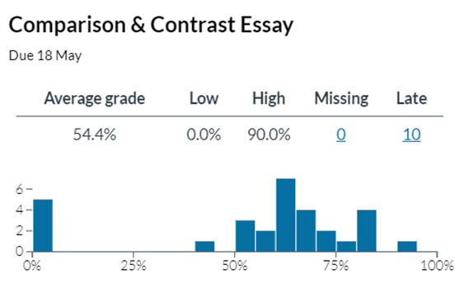
Figure 1. Comparison–Contrast Essay score distribution (x-axis = score %, y-axis = number of students).
The comparison–contrast task showed an average grade of 54.4% with observed scores ranging from 0% to 90% (Figure 1). The distribution indicates substantial dispersion, including a low-score cluster at 0% (interpretable as non-performance or non-submission) and a mid-to-upper cluster between approximately 55% and 80%. Ten submissions were recorded as late.

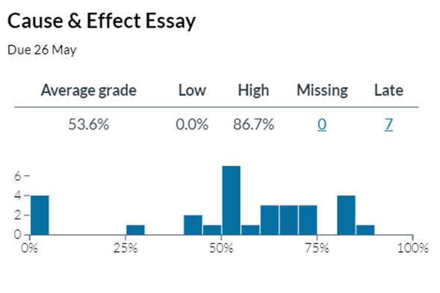
Figure 2. Cause–Effect Essay score distribution (x-axis = score %, y-axis = number of students).
The cause–effect task yielded an average grade of 53.6% with scores ranging from 0% to 86.7% (Figure 2). The overall mean remained similar to the prior genre, while the distribution again suggests heterogeneous attainment. Seven submissions were recorded as late.

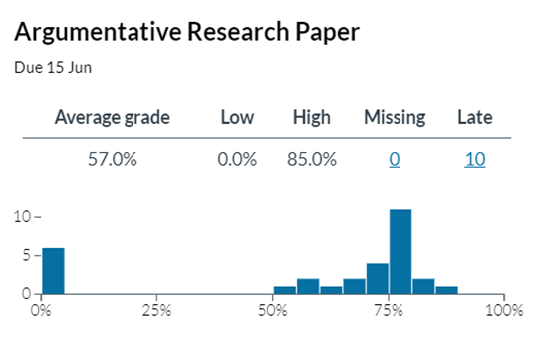
Figure 3. Argumentative Research Paper score distribution (x-axis = score %, y-axis = number of students).
For the argumentative research paper, the average grade increased modestly to 57.0%, with observed scores from 0% to 85% (Figure 3). The distribution shows a pronounced cluster in the 70–80% range, consistent with improved control of macro-structure for argumentation, alongside continued low-end outcomes. Ten submissions were recorded as late.
4.2 LMS Engagement Trends

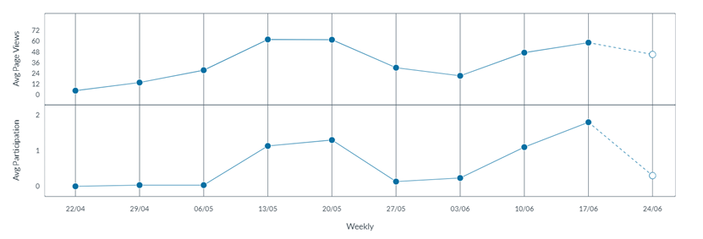
Figure 4. Weekly LMS engagement trends (top panel = average page views; bottom panel = average participation events).
Across the term, average page views increased toward mid-term and again near the period in which the final research paper was due (Figure 4). Participation events were comparatively low and only increased modestly near major assessment points. These trends suggest assessment-driven engagement spikes rather than stable interaction routines.
5. Discussion
The performance charts support a more nuanced interpretation than single averages alone. Across the three genres, mean performance shifted only modestly (≈54% → 54% → 57%), but the distributions show persistent dispersion and a recurring low-end cluster. From a genre-based perspective, this pattern is consistent with uneven acquisition of genre control: some students consolidate macro-organization and task adherence, while others struggle with foundational participation, drafting, or meeting minimum criteria.
Importantly, the charts do not themselves diagnose which subskills drove scores. Their value lies in triangulation: when paired with analytic rubrics and instructor observations, distributions can help identify where targeted scaffolding is most needed (e.g., thesis control and paragraph development early; source integration, synthesis, and citation conventions in the research paper).
The engagement trends provide contextual signals rather than explanatory evidence. Page views rose near deadlines, suggesting preparatory exposure; however, low participation indicates limited dialogic or peer-supported drafting practices. Where programs aim to promote writing development through iterative feedback and interaction, these engagement indicators can flag underutilization of collaborative spaces and motivate redesign (e.g., structured peer review cycles with participation credit).
Taken together, performance charts operationalize a practical middle ground between informal “teacher intuition” and heavy-weight psychometric modeling: they are transparent, replicable, and useful for local decision-making, provided that interpretations remain appropriately bounded and supported by rubric evidence.
6. Implications and Conclusion
This study proposes a replicable workflow for turning routine EAP assessment and LMS data into interpretable performance charts. For practice, the charts can be used in three ways: (a) cohort diagnostics (identifying dispersion and at-risk clusters), (b) genre sequence review (checking whether planned scaffolds coincide with distributional improvement), and (c) engagement-informed redesign (evaluating whether course interaction structures support sustained writing development).
To avoid confusion between evidence and inference, instructional implications should be explicitly derived from observed chart patterns and rubric evidence, rather than placed alongside student output as equivalent categories. Future work should (i) report dimension-level rubric profiles, (ii) include transparent rater reliability evidence, and (iii) extend analysis longitudinally across subsequent courses to examine whether charted performance patterns predict downstream academic attainment.
Because the present analysis is descriptive and context-specific, its primary contribution is methodological: it clarifies what is being measured, how it is visualized, and how such visualization can be used responsibly in EAP program development.

References
Afflerbach, P. (2017). Understanding and using reading assessment, K–12. International Literacy Association.
Alimalayeri, R., Himmelreich, B., Gundarina, O., & Marinkova, M. (2021). “Conline” teaching: Creative pedagogy as a conduit to EAP practitioners’ agency. [Working paper].
Bailey, S. (2018). Academic writing: A handbook for international students (5th ed.). Routledge.
Biesta, G., Priestley, M., & Robinson, S. (2015). The role of beliefs in teacher agency. Teachers and Teaching, 21(6), 624–640. https://doi.org/10.1080/13540602.2015.1044325
Coffin, C., Curry, M. J., Goodman, S., Hewings, A., Lillis, T. M., & Swann, J. (2003). Teaching academic writing: A toolkit for higher education. Routledge.
Grabe, W., & Zhang, C. (2013). Reading and writing together: A critical component of EAP teaching and learning. TESOL Journal, 4(1), 9–24. https://doi.org/10.1002/tesj.65
Hyland, K. (2019). Second language writing (2nd ed.). Cambridge University Press.
Jordan, R. R. (2020). English for academic purposes: A guide and resource book for teachers. Cambridge University Press.
Knoch, U. (2009). Diagnostic writing assessment: The development and validation of a rating scale. Peter Lang.
Luke, A., & Freebody, P. (1997). Shaping the social practices of reading. In S. Muspratt, A. Luke, & P. Freebody (Eds.), Constructing critical literacies (pp. 185–225). Allen & Unwin.
Paris, D., & Hamilton, E. (2009). The ethnography of learning: A conceptual framework. American Educational Research Journal, 46(1), 1–29.
Wingate, U. (2012). Using academic literacies and genre-based models for academic writing instruction: A ‘literacy’ journey. Journal of English for Academic Purposes, 11(1), 26–37. https://doi.org/10.1016/j.jeap.2011.11.006

DOIs are provided where available; several foundational sources cited in this study are monographs or edited volumes for which DOIs are not assigned.

